Test Case Header:
Application GNUKhata Web Application Test Case Name: test_user.py
Test Case ID: S-11

Test Description:
rpc_user.py has functions xmlrpc_setUser, xmlrpc_getUser, xmlrpc_changepassword.
test_user.py tests these functions with the help of four test case conditions.
test_type_ setUser checks if the api function returns the output as a boolean which is set to true when the api function is executed. The result is asserted.
test_right_ setUser takes the correct input and checks if the api function is functioning properly under the right input test.
test_wrongdata_ setUser takes the incorrect input and checks if the api function is setting the values. The function should not return true in this case, which is checked.
test_multi_ setUser executes the api function multiple times to check the behaviour of the function in such condition.
Similarly remaining functions are also checked.

Inputs:
It takes input as username and password.

Outputs:
All the test cases with right input passes and with wrong input fails.

Test Case Header:
Application GNUKhata Web Application Test Case Name: test_voucher.py
Test Case ID: S-12

Test Description:
rpc_voucher.py has functions xmlrpc_setVoucher, xmlrpc_getVoucher, xmlrpc_getVoucherCode, xmlrpc_getSpecificVoucherCode.
test_voucher.py tests these functions with the help of four test case conditions.
test_type_ setVoucher checks if the api function returns the output as a boolean which is set to true when the api function is executed. The result is asserted.
test_right_ setVoucher takes the correct input and checks if the api function is functioning properly under the right input test.
test_wrongdata_ setVoucher takes the incorrect input and checks if the api function is setting the values. The function should not return true in this case, which is checked.
test_multi_ setVoucher executes the api function multiple times to check the behaviour of the function in such condition.
Similarly remaining functions are also checked.

Inputs:
It takes input from VoucherMaster and VoucherDetails table stored in database.

Outputs:
All the test cases with right input passes and with wrong input fails.

Test Case Header:
Application GNUKhata Web Application Test Case Name: test_purchasebill.py
Test Case ID: S-13

Test Description:
rpc_purchasebill .py has functions xmlrpc_setPurchaseBill, xmlrpc_getPurchaseMaster, xmlrpc_getPurchaseDetails, xmlrpc_getPurchaseDetailsByProductCode, xmlrpc_editPurchaseBill, xmlrpc_getAmount,
test_purchasebill.py tests these functions with the help of four test case conditions.
test_type_ getPurchaseDetails checks if the api function returns the output as a list which when the api function is executed. The result is asserted for the data type checking.
test_right_getPurchaseDetails takes the correct input and checks if the api function is functioning properly under the right input test.
test_wrongdata_ getPurchaseDetails takes the incorrect input and checks if the api function is setting the values. The function should not return true in this case, which is checked.
test_multi_ getPurchaseDetails executes the api function multiple times to check the behaviour of the function in such condition.
Similarly remaining functions are also checked.

Inputs:
It takes input from PurchaseMaster and PurchaseDetails stored in database.

Outputs:
All the test cases with right input passes and with wrong input fails.

Test Case Header:
Application GNUKhata Web Application Test Case Name: test_reports.py
Test Case ID: S-14

Test Description:
rpc_reports.py has only one function xmlrpc_getTrialBalance.
test_reports.py tests these functions.
test_right_getTrialBalance takes the correct input and checks if the api function is functioning properly under the right input test.
test_multi_ getTrialBalance executes the api function multiple times to check the behaviour of the function in such condition.

Inputs:
It takes input integer.

Outputs:
All the test cases with right input passes and with wrong input fails.

Test Case Header:
Application GNUKhata Web Application Test Case Name: test_salesbill.py
Test Case ID: S-15

Test Description:
rpc_salesbill.py has functions xmlrpc_setSalesBill, xmlrpc_getSalesMaster, xmlrpc_getSalesDetails, xmlrpc_getSalesDetailsByProductCode, xmlrpc_editSalesBill, xmlrpc_getAmount,
test_salesbill.py tests these functions with the help of four test case conditions.
test_type_ getSalesDetails checks if the api function returns the output as a list which when the api function is executed. The result is asserted for the data type checking.
test_right_getSalesDetails takes the correct input and checks if the api function is functioning properly under the right input test.
test_wrongdata_ getSalesDetails takes the incorrect input and checks if the api function is setting the values. The function should not return true in this case, which is checked.
test_multi_ getSalesDetails executes the api function multiple times to check the behaviour of the function in such condition.
Similarly remaining functions are also checked.

Inputs:
It takes input from SalesMaster and SalesDetails table stored in database.

Outputs:
All the test cases with right input passes and with wrong input fails.

Test Case Header:
Application GNUKhata Web Application Test Case Name: test_salesvoucher.py
Test Case ID: S-16

Test Description:
rpc_salesvoucher.py has functions xmlrpc_setSalesBook, xmlrpc_getSalesBook, xmlrpc_editSalesBook.
test_salesvoucher.py tests these functions with the help of four test case conditions.
test_type_setSalesBook checks if the api function returns the output as a boolean which returns true when the api function is executed. The result is asserted for the data type checking.
test_right_ setSalesBook takes the correct input and checks if the api function is functioning properly under the right input test.
test_wrongdata_ setSalesBook takes the incorrect input and checks if the api function is setting the values. The function should not return true in this case, which is checked.
test_multi_ setSalesBook executes the api function multiple times to check the behaviour of the function in such condition.
Similarly remaining functions are also checked.

Inputs:
It takes input related salesbook.

Outputs:
All the test cases with right input passes and with wrong input fails.

Test Case Header:
Application GNUKhata Web Application Test Case Name: test_purchasereturn.py
Test Case ID: S-17

Test Description:
rpc_purchasereturn.py has functions xmlrpc_setPurchaseReturn, xmlrpc_getPurchaseReturn, xmlrpc_getPrevPurchaseReturn, xmlrpc_getPurchaseReturnQuantity, xmlrpc_editPurchaseReturn,
test_purchasereturn.py tests these functions with the help of four test case conditions.
test_type_ getPurchaseReturn checks if the api function returns the output as a list when the api function is executed. The result is asserted for the data type checking.
test_right_ getPurchaseReturn takes the correct input and checks if the api function is functioning properly under the right input test.
test_wrongdata_ getPurchaseReturn takes the incorrect input and checks if the api function is setting the values. The function should not return true in this case, which is checked.
test_multi_getPurchaseReturn executes the api function multiple times to check the behaviour of the function in such condition.
Similarly remaining functions are also checked.

Inputs:
It takes input from PurchaseReturnDetails and PurchaseReturnMaster stored in database.

Outputs:
All the test cases with right input passes and with wrong input fails.

Test Case Header:
Application GNUKhata Web Application Test Case Name: test_ledger.py
Test Case ID: S-18

Test Description:
rpc_ledger.py has functions xmlrpc_setLedger, xmlrpc_getDetailsByLedger, xmlrpc_getDetailsOfSundryDebtors, xmlrpc_getDetailsOfSundryCreditors, xmlrpc_getDetailsByLedgerInDate, xmlrpc_getGeneralLedger, xmlrpc_getGeneralReportIncome, xmlrpc_getGeneralReportExpense, xmlrpc_getGeneralReport, xmlrpc_editLedger.
test_ledger.py tests these functions with the help of four test case conditions.
test_type_ getDetailsByLedger checks if the api function returns the output as a list when the api function is executed. The result is asserted for the data type checking.
test_right_getDetailsByLedger takes the correct input and checks if the api function is functioning properly under the right input test.
test_wrongdata_getDetailsByLedger takes the incorrect input and checks if the api function is setting the values. The function should not return true in this case, which is checked.
test_multi_getDetailsByLedger executes the api function multiple times to check the behaviour of the function in such condition.
Similarly remaining functions are also checked.

Inputs:
It takes input related to ledger.

Outputs:
All the test cases with right input passes and with wrong input fails.

Test Case Header:
Application GNUKhata Web Application Test Case Name: test_tax.py
Test Case ID: S-19

Test Description:
rpc_tax.py has functions xmlrpc_setTax, xmlrpc_getTax, xmlrpc_editTax, xmlrpc_getTaxNames, xmlrpc_getAllTaxes.
test_tax.py tests these functions with the help of four test case conditions.
test_type_ getTax checks if the api function returns the output as a list when the api function is executed. The result is asserted for the data type checking.
test_right_getTax takes the correct input and checks if the api function is functioning properly under the right input test.
test_wrongdata_getTax takes the incorrect input and checks if the api function is setting the values. The function should not return true in this case, which is checked.
test_multi_getTax executes the api function multiple times to check the behaviour of the function in such condition.
Similarly remaining functions are also checked.

Inputs:
It takes input from Tax table stored in database.

Outputs:
All the test cases with right input passes and with wrong input fails.

Test Case Header:
Application GNUKhata Web Application Test Case Name: test_oraganisation.py
Test Case ID: S-20

Test Description:
rpc_oraganisation.py has functions xmlrpc_getOrganisation, xmlrpc_setOrganisation, xmlrpc_editOrganisation, xmlrpc_getOrganisationNames, xmlrpc_getAllOrganisation.
test_organisation.py tests these functions with the help of four test case conditions.
test_type_setOrganisation checks if the api function returns the output as a boolean which returns true when the api function is executed. The result is asserted for the data type checking.
test_right_setOrganisation takes the correct input and checks if the api function is functioning properly under the right input test.
test_wrongdata_ setOrganisation takes the incorrect input and checks if the api function is setting the values. The function should not return true in this case, which is checked.
test_multi_setOrganisation executes the api function multiple times to check the behaviour of the function in such condition.
Similarly remaining functions are also checked.

Inputs:
It takes input from organisation table stored in database.

Outputs:
All the test cases with right input passes and with wrong input fails.

Test Case Header:
Application GNUKhata Web Application Test Case Name: test_groups.py
Test Case ID: S-21

Test Description:
test_groups.py is the test file to check the API rpc_groups.py. This test includes the test cases to test the functions in rpc_groups.py
In setUp method of test_groups we connect to the xmlrpc lib server by giving the existing databasename and financial year.
test_right_setGroups method calls for the function setGroups to execute by passing the right inputs to the function and checks whether the application gives right output.
test_right_getGroupByCode calls for the function xmlrpc_getGroupByCode by passing correct group code and checks whether application generates correct group details from group code.
test_right_getGroupByName calls for the function xmlrpc_getGroupByName by passing correct group name and checks whether application generates correct group details from group name.
test_right_getGroupNameByAccountName calls for the function xmlrpc_ getGroupNameByAccountName by passing correct account name and checks whether application generates correct group details.
test_right_getAllGroups executes function xmlrpc_getAllGroups and checks whether application generates list of all groups.
test_right _updateGroupBalance and test_right_editGroups execute functions xmlrpc_updateGroupBalance and xmlrpc_editGroups and check whether application properly edits group details.
test_type_setGroups, test_type_updateGroupBalance, test_type_editGroups check whether the data type of output of the functions xmlrpc_setGroups, xmlrpc_updateGroupBalance and xmlrpc_ editGroups is 'boolean'.
test_type_getGroupByCode, test_type_getAllGroups, test_type_getGroupByName, tes_type_getGroupNames and test_type_getGroupNameByAccountName check whether the data type of output of functions xmlrpc_getGroupByCode, xmlrpc_getAllGroups, xmlrpc_getGroupByName, xmlrpc_getGroupNames and xmlrpc_getGroupNameByAccountName is 'list'.
test_wrongdata_setGroups, test_wrongdata_editGroups and test_wrongdata_updateGroupBalance calls for the functions xmlrpc_setGroups and xmlrpc_editGroups and check for response of these functions when wrong data is provided.
Tesing of xmlrpc_getGroupByCode, xmlrpc_getAllGroups, xmlrpc_getGroupNames, xmlrpc_getGroupByName and xmlrpc_getGroupNameByAccountName functions is done in same way.
test_multi_setGroups calls for the function repeatedly to check the response of the function xmlrpc_setGroup.
The testing of the function xmlrpc_editGroups,xmlrpc_updateGroupBalance, xmlrpc_getGroupByCode, xmlrpc_getGroupByName,xmlrpc_getAllGroups, xmlrpc_getGroupNames, xmlrpc_getGroupNameByAccountName is done in the same way.

Inputs:
test_right_setGroups ,test_requires input list from Groups table containing group code,group name,subgroup name and opening balance.
test_right getAllGroups requires client_id as input. test_right_getGroupNameByAccountName requires account name as input.
Outputs:
test_right_getAllGroups function returns list of all groups as output.
test_right_getGroupByCode and test_right_getGroupByName return group details as ouput.

Test Case Header:
Application GNUKhata Web Application Test Case Name: test_cashbook.py
Test Case ID: S-22

Test Description:
rpc_cashbook.py has functions xmlrpc_setCashBook, xmlrpc_getVoucher, xmlrpc_editVoucher.
test_cashbook.py tests these functions with the help of four test case conditions.
test_type_ setCashBook checks if the api function returns the output as a boolean which is set to true when the api function is executed. The result is asserted.
test_right_ setCashBook takes the correct input and checks if the api function is functioning properly under the right input test.
test_wrongdata_ setCashBook takes the incorrect input and checks if the api function is setting the values. The function should not return true in this case, which is checked.
test_multi_ setCashBook executes the api function multiple times to check the behaviour of the function in such condition.
Similarly remaining functions are also checked.

Inputs:
test_right_setCashBook takes 2 input lists from VoucherMaster table and VoucherDetails table.

Outputs: All right input tests passed and all wrong input tests failed

Test Case Header:
Application GNUKhata Web Application Test Case Name: test_cashmemo.py
Test Case ID: S-23

Test Description:
rpc_cashmemo.py has functions xmlrpc_setCashMemo, xmlrpc_getCashMemo, xmlrpc_getCashMemoByReferenceNo.
test_cashmemo.py tests these functions with the help of four test case conditions.
test_type_setCashMemo checks if the api function returns the output as a boolean which is set to true when the api function is executed. The result is asserted.
test_right_ setCashMemo takes the correct input and checks if the api function is functioning properly under the right input test.
test_wrongdata_ setCashMemo takes the incorrect input and checks if the api function is setting the values. The function should not return true in this case, which is checked.
test_multi_ setCashMemo executes the api function multiple times to check the behaviour of the function in such condition.
Similarly remaining functions are also checked.

Inputs:
test_right_setCashMemo takes input list from CashMemo table.

Outputs: All right input tests passed and all wrong input tests failed

Test Case Header:
Application GNUKhata Web Application Test Case Name: test_salesreturn.py
Test Case ID: S-24

Test Description:
rpc_salesreturn.py has functions xmlrpc_setSalesReturn, xmlrpc_getSalesReturn, xmlrpc_getPrevSalesReturn,xmlrpc_getSalesReturnQuantity,xmlrpc_edit.
test_salesreturn.py tests these functions with the help of four test case conditions.
test_type_setSalesReturn checks if the api function returns the output as a boolean which is set to true when the api function is executed. The result is asserted.
test_right_ setSalesReturn takes the correct input and checks if the api function is functioning properly under the right input test.
test_wrongdata_ setSalesReturn takes the incorrect input and checks if the api function is setting the values. The function should not return true in this case, which is checked.
test_multi_ setSalesReturn executes the api function multiple times to check the behaviour of the function in such condition.
Similarly remaining functions are also checked.

Inputs:
test_right_setSalesReturn takes input list from SalesReturnMaster table.
test_right_getSalesReturnQuantity takes input list from StockQty table.

Outputs: All right input tests passed and all wrong input tests failed

Test Case Header:
Application GNUKhata Web Application Test Case Name: test_customizable.py
Test Case ID: S-25

Test Description:
rpc_customizable .py has two functions xmlrpc_setCustomizable, xmlrpc_getCustomCode.
test_tax.py tests these functions with the help of four test case conditions.
test_type_getCustomCode checks if the api function returns the output as a list when the api function is executed. The result is asserted for the data type checking.
test_right_getCustomCode takes the correct input and checks if the api function is functioning properly under the right input test.
test_wrongdata_getCustomCode takes the incorrect input and checks if the api function is setting the values. The function should not return true in this case, which is checked.
test_multi_getCustomCode executes the api function multiple times to check the behaviour of the function in such condition.
Similarly remaining functions are also checked.

Inputs:
It takes input from CustomizableDetails and CustomizableMaster table stored in database.

Outputs:
All the test cases with right input passes and with wrong input fails.

Test Case Header:
Application GNUKhata Web Application Test Case Name:test_purchasevoucher.py
Test Case ID: S-26

Test Description:
rpc_purchasevoucher .py has two functions xmlrpc_setPurchaseBook, xmlrpc_getPurchaseBook, xmlrpc_editPurchaseBook,
test_purchasevoucher.py tests these functions with the help of four test case conditions.
test_type_getPurchaseBook checks if the api function returns the output as a list when the api function is executed. The result is asserted for the data type checking.
test_right_ getPurchaseBook takes the correct input and checks if the api function is functioning properly under the right input test.
test_wrongdata_ getPurchaseBook takes the incorrect input and checks if the api function is setting the values.
test_multi_ getPurchaseBook executes the api function multiple times to check the behaviour of the function in such condition.
Similarly remaining functions are also checked.

Inputs:
It takes input related to purchase form.

Outputs:
All the test cases with right input passes and with wrong input fails.

Tests for client side:
URL
This test emulates requests to the web application by utilizing webtest. This test checks whether the response was handled appropriately and the controller set things up properly.
Test Pass: Test must pass if all the urls are working.
Test Fail: Test must fail for dead link.

Tests documentation: Client side
Test case Header:

Application: Gnukhata Web Application Test case Name: test_account.py
Test case Id: C-01
Test case Description:
Account controller has functions: index, setAccount, getAccount, getBasedon, get Balance. Test file contains class TestAccountController which contains test cases for checking response of url.

Input: url
Output: all test cases passed

Test case Header:

Application: Gnukhata Web Application Test case Name: test_category.py
Test case Id: C-02
Test case Description:
Category controller has functions: index, customise, setCategory . Test file contains class TestCategoryController which contains test cases for checking response of url.

Input: url
Output: all test cases passed

Test case Header:

Application: Gnukhata Web Application Test case Name: test_contra.py
Test case Id: C-03
Test case Description:
Contra controller has functions: index, setVoucher, getVoucher, getCashBook, getContraAccounts, getAllBankAccount. Test file contains class TestContraController which contains test cases for checking response of url.

Input: url
Output: all test cases passed

Test case Header:

Application: Gnukhata Web Application Test case Name: test_createuser.py
Test case Id: C-04
Test case Description:
Createuser controller has functions: index. Test file contains class TestCreateuserController which contains test cases for checking response of url.

Input: url
Output: all test cases passed

Test case Header:

Application: Gnukhata Web Application Test case Name: test_credit.py
Test case Id: C-05
Test case Description:
Credit controller has functions: index, getBasedon, getGroup, setCredit. Test file contains class TestCreditController which contains test cases for checking response of url.

Input: url
Output: all test cases passed

Test case Header:

Application: Gnukhata Web Application Test case Name: test_customer.py
Test case Id: C-06
Test case Description:
Customer controller has functions: index, setCustomer, getCustomer, selectCustomer, editCustomer, getCities, getStates. Test file contains class TestCustomerController which contains test cases for checking response of url.

Input: url
Output: all test cases passed

Test case Header:

Application: Gnukhata Web Application Test case Name: test_customization.py
Test case Id: C-07
Test case Description:
Customization controller has functions: index, addCustomize, getCustomize, editCustomize. Test file contains class TestCustomizationController which contains test cases for checking response of url.

Input: url
Output: all test cases passed

Test case Header:

Application: Gnukhata Web Application Test case Name: test_debit.py
Test case Id: C-08
Test case Description:
Debit controller has functions: index, getBasedon, getGroup, setDebit.. Test file contains class TestDebitController which contains test cases for checking response of url.

Input: url
Output: all test cases passed

Test case Header:

Application: Gnukhata Web Application Test case Name: test_journal.py
Test case Id: C-09
Test case Description:
Journal controller has functions: index, setVoucher, getVoucher, getCashBook, getAllAccounts, getAllBankAccount.. Test file contains class TestJournalController which contains test cases for checking response of url.

Input: url
Output: all test cases passed

Test case Header:

Application: Gnukhata Web Application Test case Name: test_payment.py
Test case Id: C-10
Test case Description:
Payment controller has functions: index, setVoucher, getVoucher, getCashBook, getAllAccounts, getAllBankAccount.. Test file contains class TestPaymentController which contains test cases for checking response of url.

Input: url
Output: all test cases passed

Test case Header:

Application: Gnukhata Web Application Test case Name: test_people.py
Test case Id: C-11
Test case Description:
People controller has functions: index, getPeopleMaster, setPeopleDetails, getPeopleDetails, getCities, getStates. Test file contains class TestPeopleController which contains test cases for checking response of url.

Input: url
Output: all test cases passed

Test case Header:

Application: Gnukhata Web Application Test case Name: test_product.py
Test case Id: C-12
Test case Description:
Product controller has functions: index, setProduct, getAllProducts, getCategorySpecs. Test file contains class TestProductController which contains test cases for checking response of url.

Input: url
Output: all test cases passed

Test case Header:

Application: Gnukhata Web Application Test case Name: test_purchase.py
Test case Id: C-13
Test case Description:
Purchase controller has functions: index. Test file contains class TestPurchaseController which contains test cases for checking response of url.

Input: url
Output: all test cases passed

Test case Header:

Application: Gnukhata Web Application Test case Name: test_receipt.py
Test case Id: C-14
Test case Description:
Receipt controller has functions: index, setVoucher, getVoucher, getCashBook, getAllAccounts, getAllBankAccount.. Test file contains class TestReceiptController which contains test cases for checking response of url.

Input: url
Output: all test cases passed

Test case Header:

Application: Gnukhata Web Application Test case Name: test_sales.py
Test case Id: C-15
Test case Description:
Sales controller has functions index. Test file contains class TestSalesController which contains test cases for checking response of url.

Input: url
Output: all test cases passed

Test case Header:

Application: Gnukhata Web Application Test case Name: test_tax.py
Test case Id: C-16
Test case Description:
Tax controller has functions index, setTax, getTax, selectTax, editTax. Test file contains class TestTaxController which contains test cases for checking response of url.

Input: url
Output: all test cases passed

Test case Header:

Application: Gnukhata Web Application Test case Name: test_vendor.py
Test case Id: C-17
Test case Description:
Vendor controller has functions index, setVendor, getVendor, selectVendor, editVendor, getCitites, getStates . Test file contains class TestVendorController which contains test cases for checking response of url.

Input: url
Output: all test cases passed

Bugs Reported:
We had pointed out the bugs on the mailing list which we came across while testing to the mailing list. We had reported about following issues.
1) Many things are not implemented at webapp for example rpc_user.py and so on hence we cannot
run the test and check for functionality.
2) We found that salesbill data is not being saved when we run webapp.
3) We also found that in creating customer and create vendor, the data is not stored according to the fields. Here is sample data we put in the fields in webapp but when we click on
"view customer" this table we saw :
Country field has postal code saved.
city field has country name
State field has phone number
postal code has state name
website field has email address
email field has credit period
credit period has website name.
Same was the case for creating vendor
Here country field has postal code
state field has city name
postal code field has state name
website field has credit period
email field has tax number
credit period field has email id and
tax number field has website stored.
4) At some places there is not enough documentation and some places its
not there.
However some of these issues are already rectified. Now the data is stored correctly in the tables.

Snapshots of gkUnit:
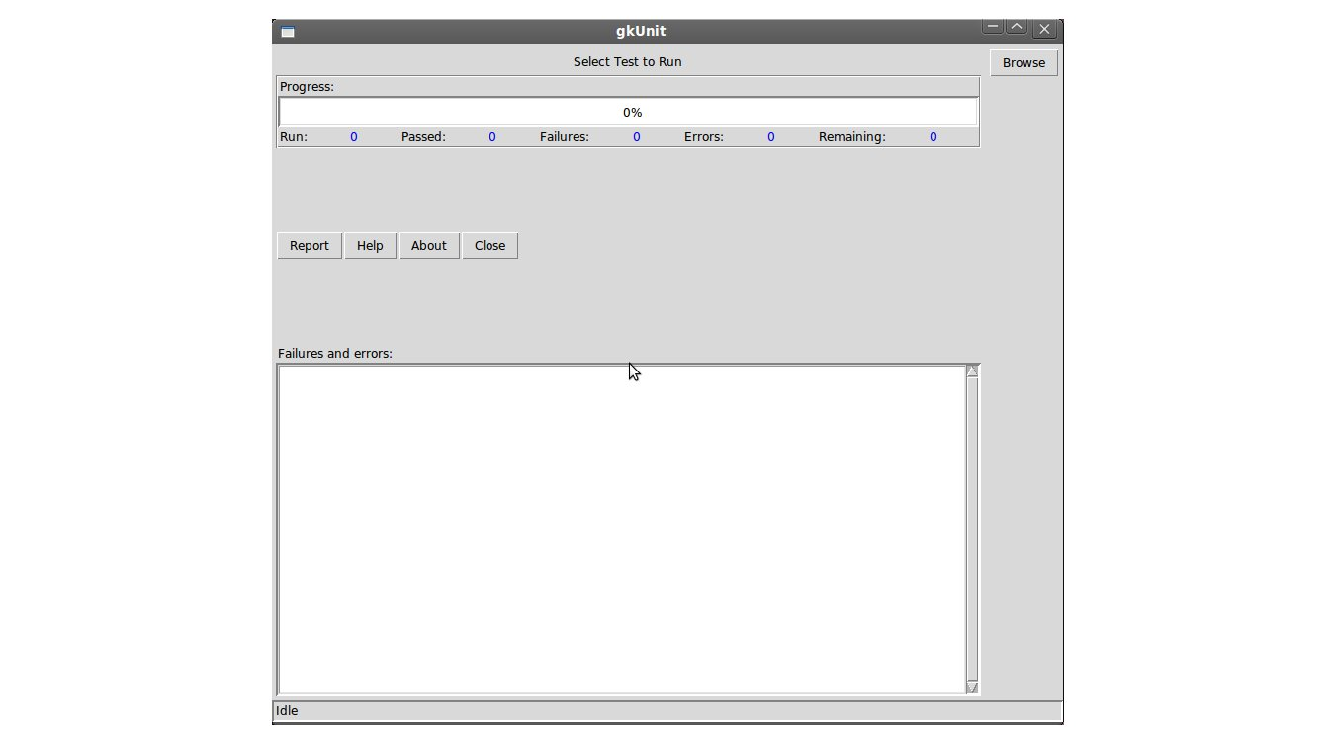
Figure 3.1: gkUnit

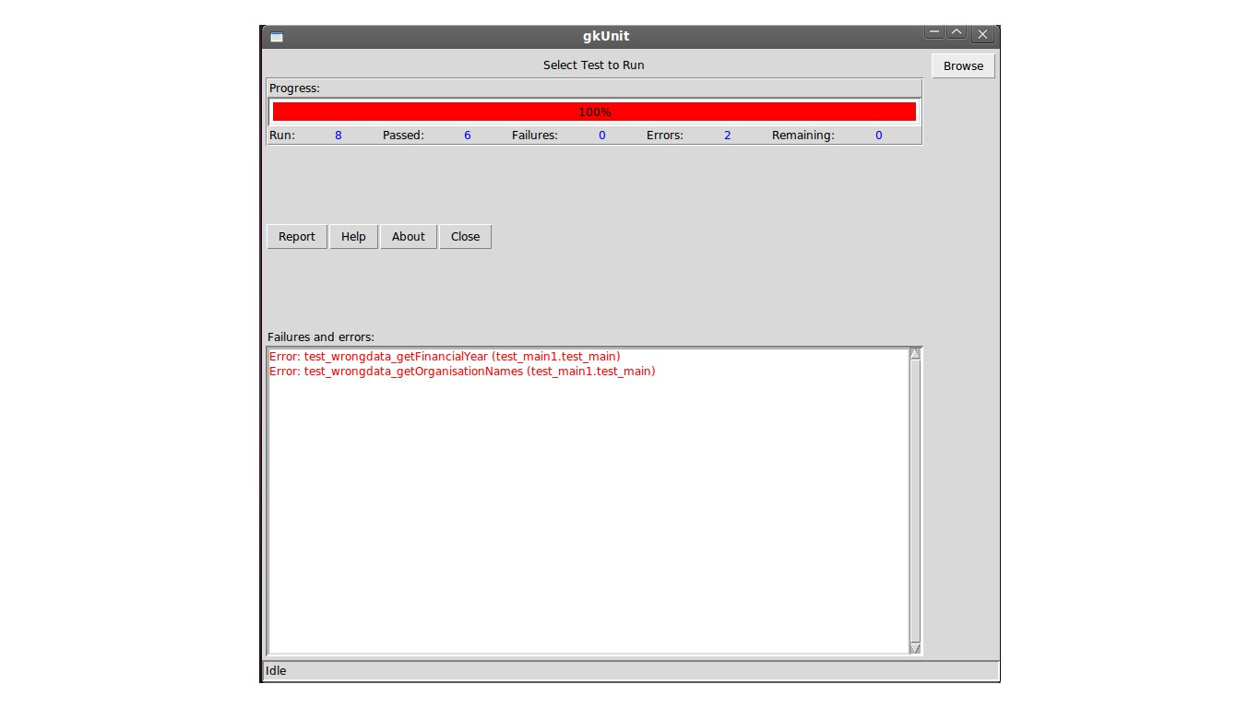
Figure 3.2: Test Result

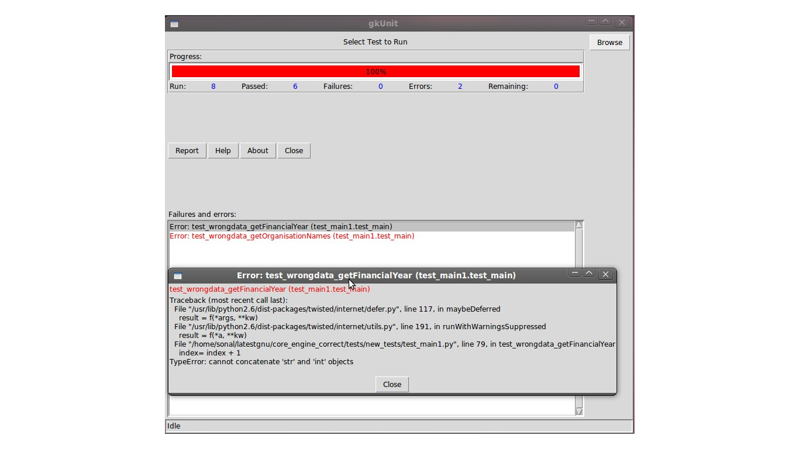
Figure 3.3: Detailed Result

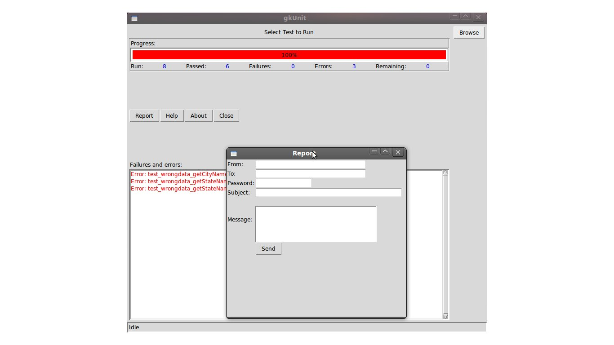
Figure 3.4: Report

3.1.2 Structure and Relationships

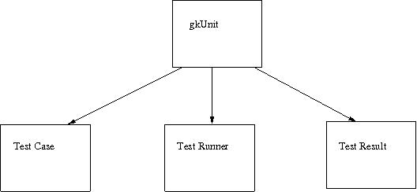
Fig 3.5 gkUnit architecture
Unit Testing Architecture:
Unit under Test: There are one or more number of classes.
Test Environment: Some variables that are used everywhere. The connection to GNUKhata Server is made.
Tests: Four kinds of test cases for each API function.
Test Execution: The connection to GNUKhata Server is made. Then test cases are run. Errors, failures, remaining are shown with description.

3.1.3 Reuse and Relationship with other products
We have used the xmlrpclib library and twisted python library for writing our test cases. Before writing the code for gkUnit we tested our test cases in trial testing framework of python-twisted.
The test cases code we have written is very modular so implementation independent and hence changing components or re-writing them will not break code.
There is one test class for each API and in the class we write different functions to check for type testing, correct input test, wrong input test and multiple time test. We write four such test functions for each original function in the API. So these test functions will be useful for writing further test cases. Also the new test functions can be added without worrying about the effects on other test function outputs.

The gkUnit framework is reusable as it can run any python test file. The server connection code can be very easily changed with respect to the different web application servers. As the source code is free to distribute, the framework can be changed according to needs of other web applications developed in python.
The test cases are dependent on the GNUKhata web application. The major changes in the APIs of the functions will reflect in the output of test cases. For example of there are changes in the input parameters for any function the test cases should be changed to check for the validity of the input and output. If there are new modules and APIs are added in web application then new test cases will be written to check for the code.

3.1.4 Design decisions and tradeoff
Design Decisions:
Test Cases:
The test cases were written at the starting keeping in mind only to check if the function is returning correct output when correct input was given. The test cases design was changed to be modular and four types of test conditions were included and they are to check the return type of the output, to check what happens when we give the wrong input to the function in the API, to check how the function behaves if the function is called repeatedly and to check the behavior of the function when correct input is given.
GUI:
The GUI of the gkUnit was decided to have the facility to view the test file. But the more important feature of reporting the errors and failures to the mailing list was included and viewing facility was discarded. When gkUnit is running it first connects to the GNUKhata server automatically and then the test cases can be run. This change in design was included while developing the gkUnit framework. The framework is included to have a report button, so the developer will be able to write to the mailing list and report to the mailing list about successfully completed tests and also the failures and errors identified by test cases. We have reported the test cases failures, errors and bugs found while we were testing the APIs to the mailing list until the gkUnit is developed.

